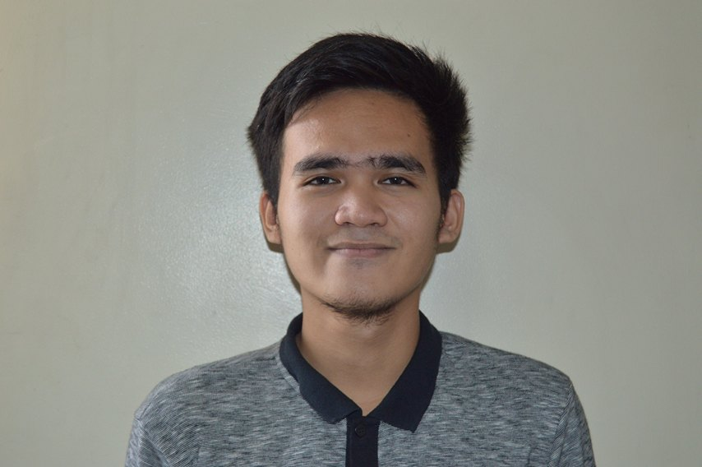**Emmanuel Jay F. Mumar**

Purok Sambag, Barangay Tisa, Cebu City

0922 773 2689

ejaymumar16@gmail.com

|  |
| --- |
| OBJECTIVES |

I am looking for a job where I could have an opportunity to put into practice my knowledge and develop my qualities while utilizing my skills.

|  |
| --- |
| PERSONAL DETAILS |

Date of Birth : October 31, 1997

Age : 19 years old

Status : Single

Gender : Male

Nationality : Filipino

Height : 5’3”

|  |
| --- |
| CONTACT DETAILS |

Email address : ejaymumar16@gmail.com

Contact number : 0922 773 2689

Home Address : Purok Sambag, Barangay Tisa, Cebu City

City : Cebu City

Province : Cebu

Zip / Postal code : 6000

|  |
| --- |
| EDUCATIONAL BACKGROUND |

Highest Education : College Level

**TERTIARY LEVEL**

Name of School : Asian College of Technology - Cebu Campus

Address : P. Del Rosario Street, Cebu City

Course : Bachelor of Science in Information Technology

Academic Year : 2014 – Present

**SECONDARY LEVEL**

Name of School : Abellana National High School

Address : Osmeña Boulevard, Cebu City

Curriculum : Computer Technology

School Year : 2010 – 2014

**PRIMARY LEVEL**

Name of School : Tisa I Elementary School

Address : F. Llamas Street, Cebu City

School Year : 2004 – 2010

|  |
| --- |
| SKILLS |

* Computer hardware troubleshooting
* Computer Literate
* Web Development
* Microsoft Office Productivity

|  |
| --- |
| CHARACTER REFERENCES |

Name : Mrs. Josephine Uy

Title : Proprietor / Manager

Contact Number : 0918 968 6900

November 14, 2016

//Name //OJT Application Letter

//Position // Sample ra ni apila lang print

//Location

Greetings!

I would like to express my sincere desire to apply for an On-The-Job training program in this company. I am Emmanuel Jay F. Mumar, a college student, currently taking up Bachelor of Science in Information Technology at Asian College of Technology.

Our course curriculum requires us to have 250-hours supervised industry training that aims to complement the concept and theories we have learned, to the development of our full potential, and to further our experiences by working in this industry through exposure to the actual field work.

Please see my enclosed resume for additional information.

Thank you for your time and consideration.

Sincerely,

**EMMANUEL JAY F. MUMAR**

*Applicant*

November 14, 2016

Dear Sir/Madam,

I would like to apply for a web developer position in your company recently posted on jobstreet.com.

I believe this position would provide a great opportunity to further my chosen career. My desire to learn more and build my skill in this field will make me a good candidate for the job. I am taking up Bachelor in Information Technology at Asia College of Technology.

I look forward to meeting with you in person to further discuss the available position.

Please see my enclosed resume for additional information.

Sincerely,

**Emmanuel Jay F. Mumar**

*Applicant*